 exercise type (Cardio, Strength, Flexibility, Balance).

Menu:

* Cardio
* Strength
* Flexibility
* Balance

This image can go for Cardio section

**Cardio**

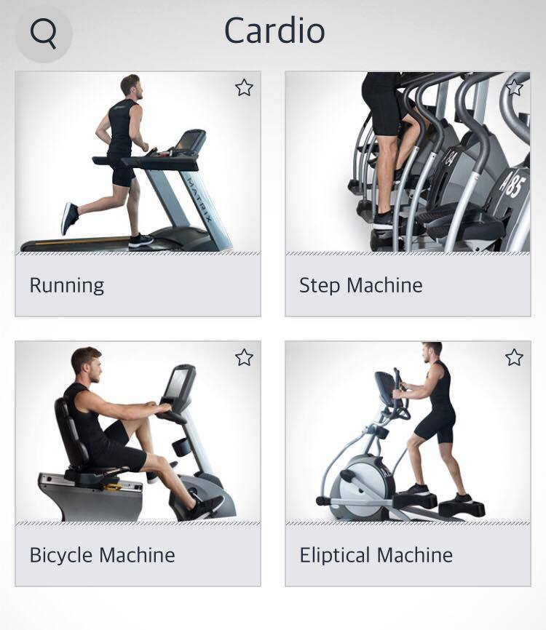

Menu

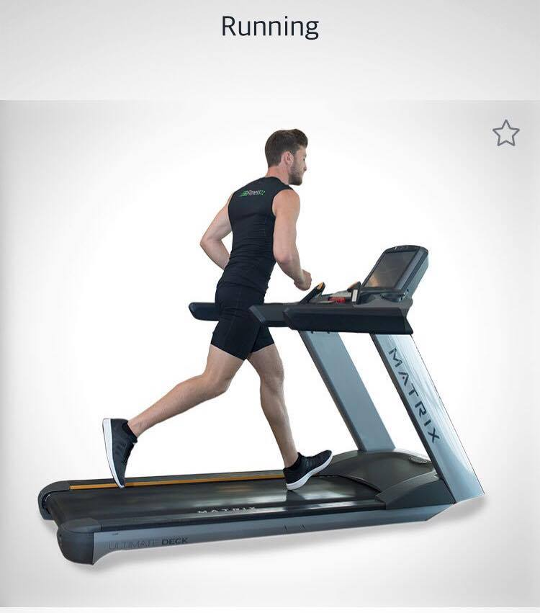

Primary muscle: Quads

Secondary: Calves

Instructions: Start with a walk and gradually speed up until you are moving at a fast, steady pace.

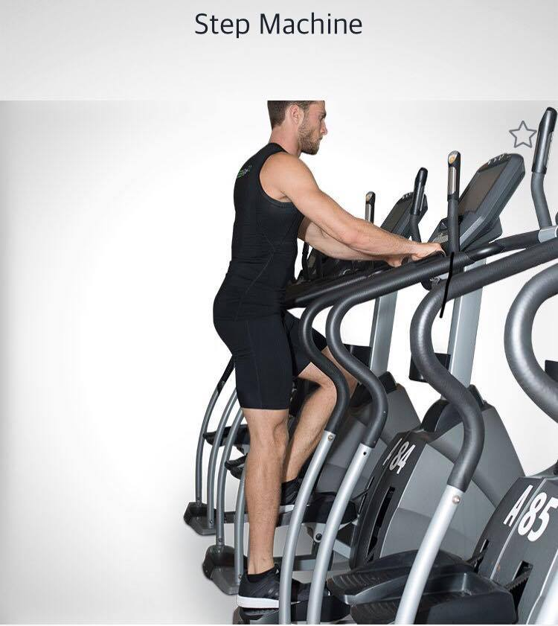

Primary muscle: Quads

Secondary: Cardio  
Instructions:

Preparation: Step onto pedal platforms and grasp hand rails.

Execution: Place your bodyweight on one pedal and allow another pedal to raise. Before the lower step hits the bottom or upper step hits top, alternate with opposite movement

Menu

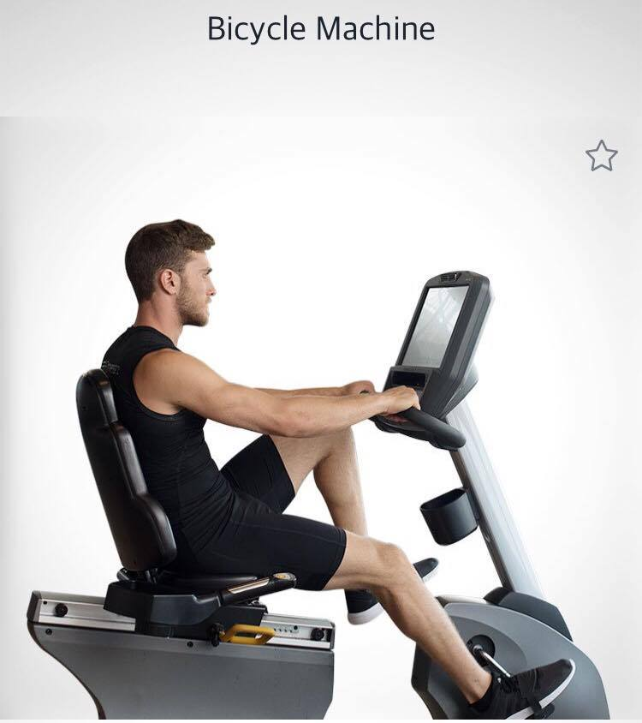

Primary muscle: Quads

Secondary: Calves  
Instructions:

Preparation: Sit down on the exercise bike, hold the grips and select quick start.

Execution: Pedal forward as you would on a bike while gripping the handles.

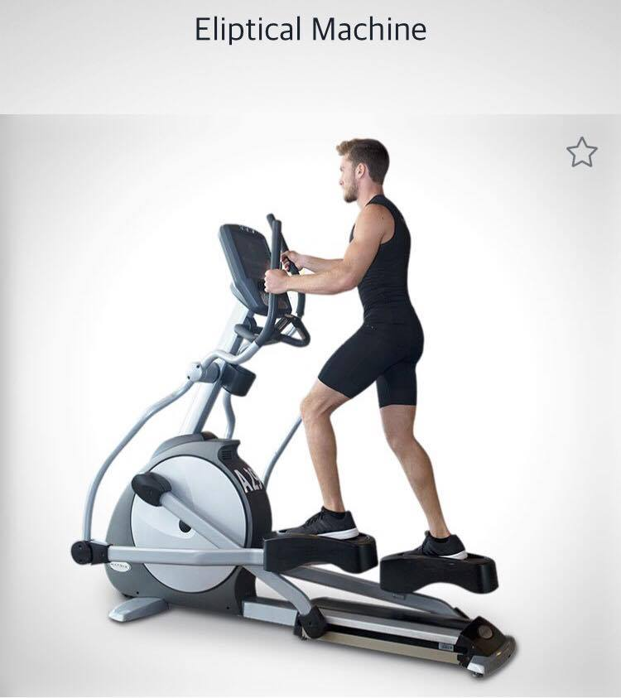

Primary muscle: Quads

Secondary: Cardio  
Instructions:

Preparation: Step on pedal platforms and grasp the handle bars on each arm lever.

Execution: Pedal forward while alternating the arm levers back and forth.

Menu

**Strength**

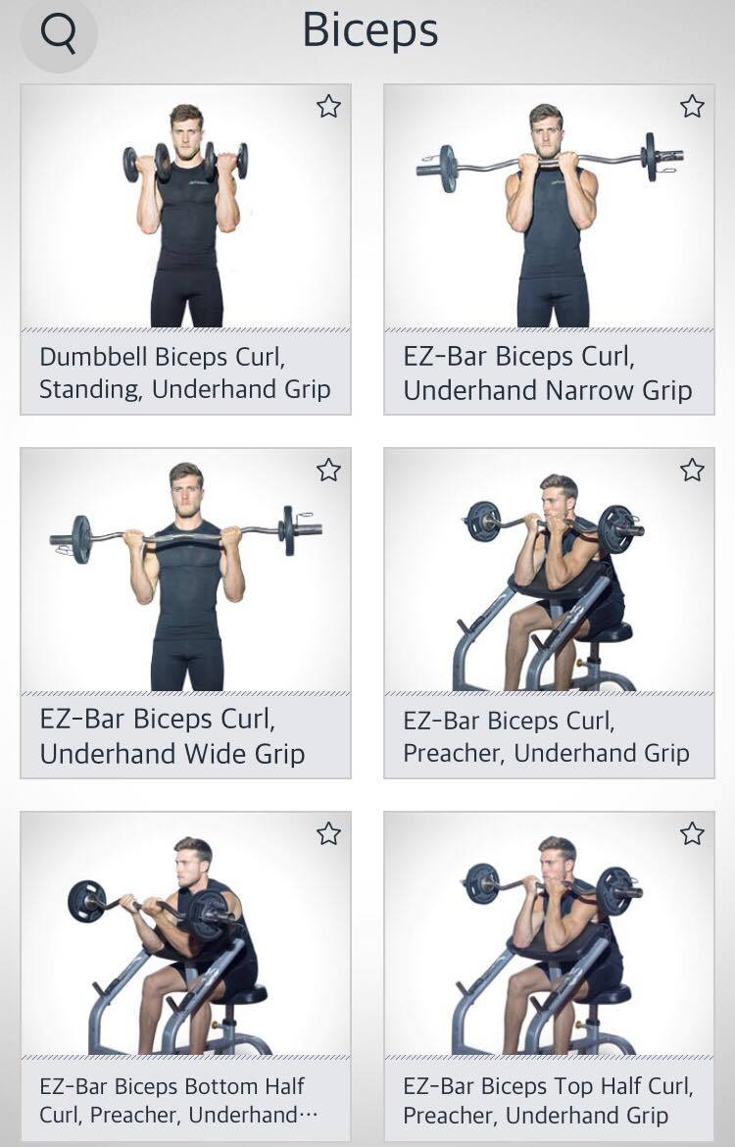

Menu

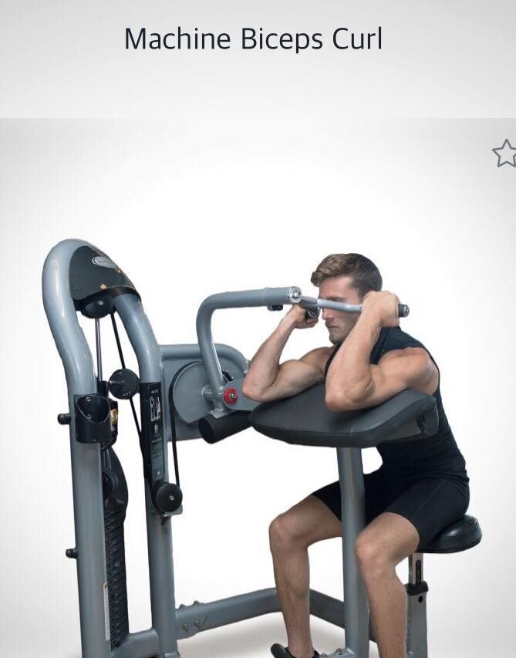

Primary muscle: Biceps  
Instructions:

Preparation: Sit down with your arms pressed against the pads and grab the handles in your desired grip type.

Execution: Keep your upper arms still, exhale, and curl the handles upwards, while contracting your biceps and repeat. Only lower the weights all the way down once you are finished with the exercise.

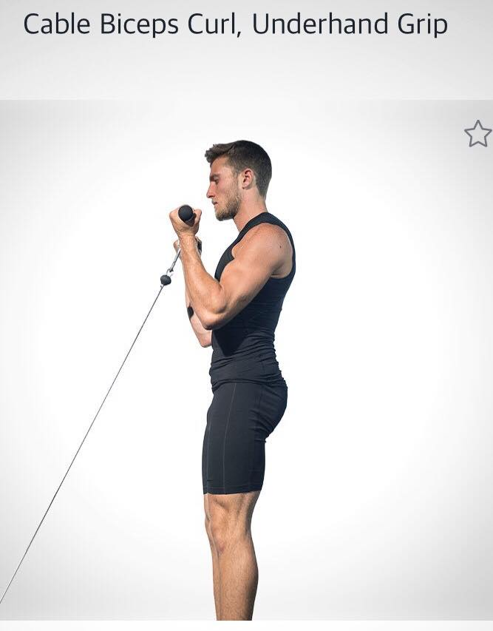

Primary muscle: Biceps  
Instructions:

Preparation: Stand with your feet shoulder width apart and grab the bar with both hands, palms facing you, while keeping your arms straight.

Execution: Bend your arms at the elbows, lifting your hands up towards your chest Lower and repeat.

Menu

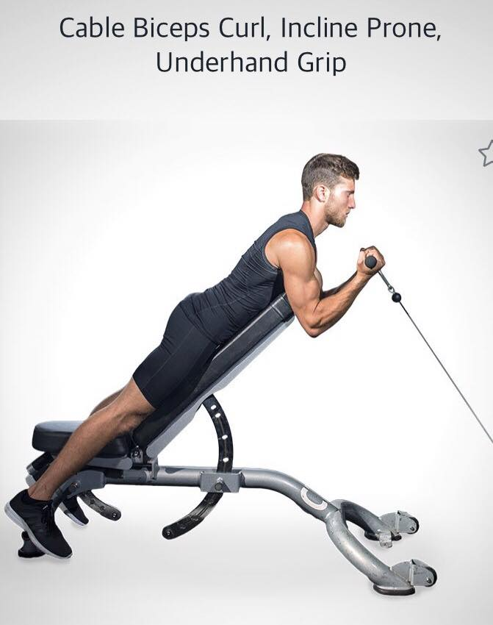

Primary muscle: Biceps  
Instructions:

Preparation: Lay face down on the incline bench and grab the bar with both hands, palms facing away from you, keeping your arms straight.

Execution: Bend your arms at the elbows, lifting your hands up towards our chest. Lower and repeat.

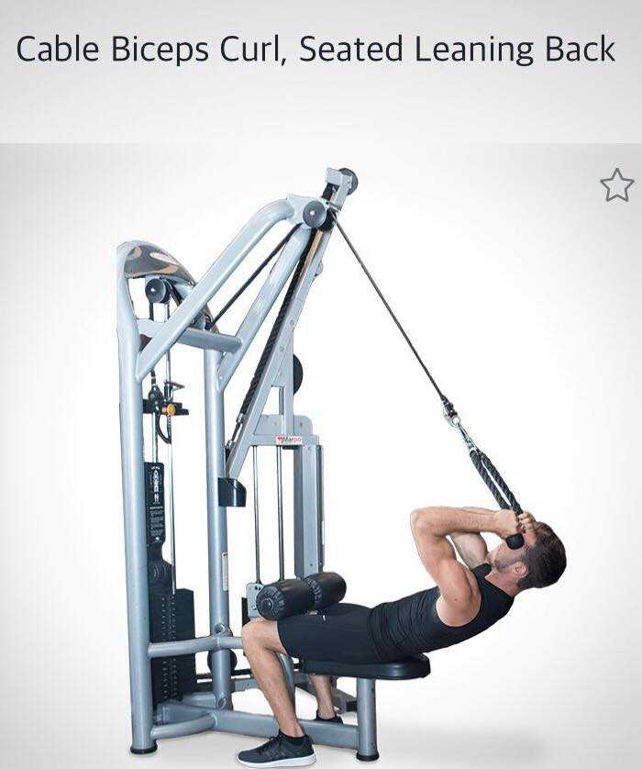

Primary muscle: Biceps  
Instructions:

Preparation: Sit at the lateral pulldown machine and attach a rope to the high pulley. Lean back as you extend your arms and hold the rope in a neutral grip.

Execution: Exhale as you curl the rope towards your head. Finish the curl with your hands on the rope on either side of your head. Return and repeat.

Menu

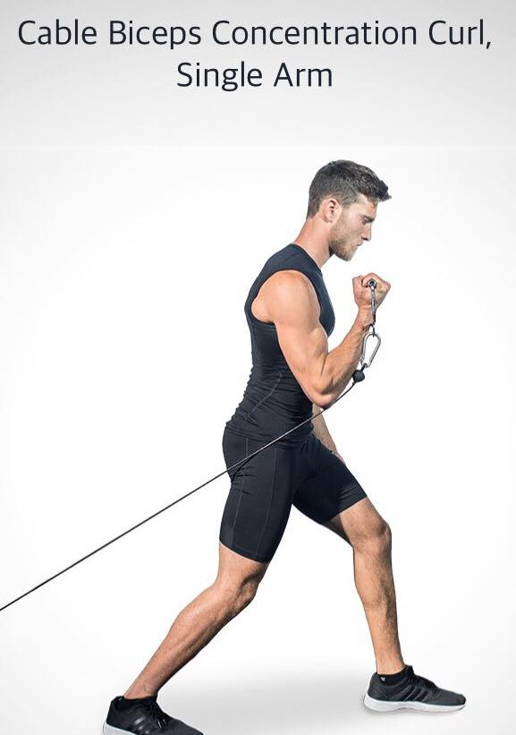

Primary muscle: Biceps  
Instructions:

Preparation: Attach a cable handle to the low pulley. Face away from the machine and grab the handle with your right hand in an underhand grip. Step forward with your left foot.

Execution: Exhale as you curl the handle up so your hand is touching your shoulder. Return to start position and repeat.

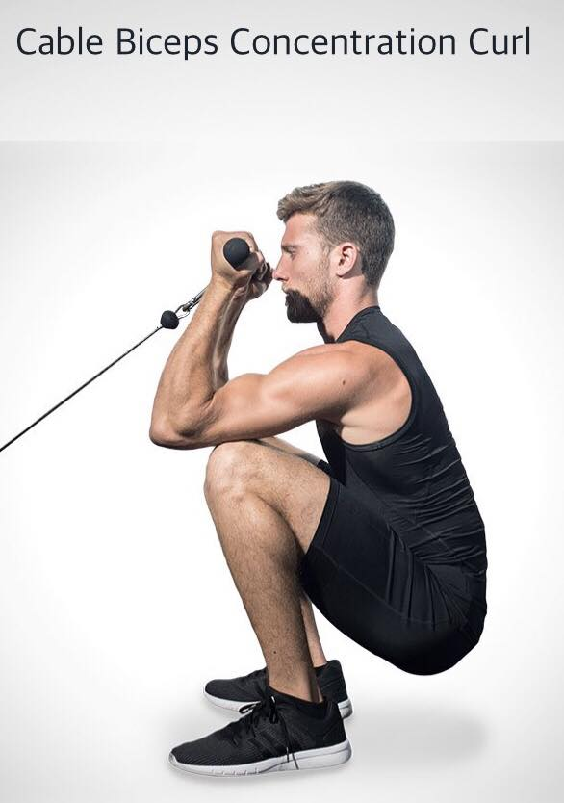

Primary muscle: Biceps  
Instructions:

Preparation: Attach the bar to the low pulley. Take a few small steps back from the machine, and squat all the way down and hold the bar in your desired grip type. Rest the top sections of your triceps on the tops of your knees.

Execution: Curl the bar up until eye-level and bring our arms back to start position with your arms extended.

Menu

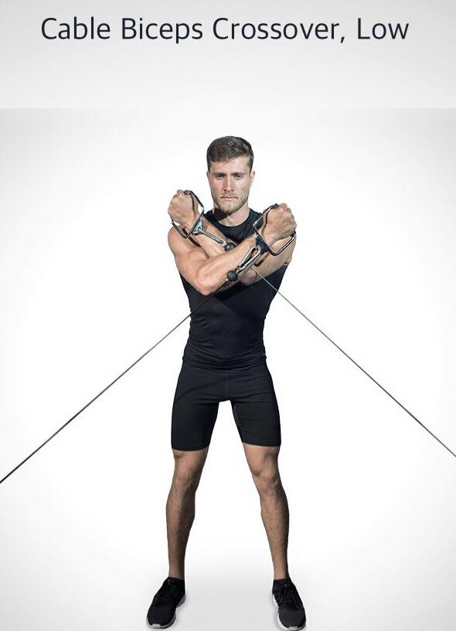

Primary muscle: Biceps

Secondary: Shoulders  
Instructions:

Preparation: Stand with your feet slightly wider than shoulder width apart. Grab the handles with both hands, palms facing forward and arms straight. Step forward, creating tension in the cables.

Execution: Bend your arms at the elbow, crossing your arms to bring your hands up towards opposite shoulder. Lower to start position and repeat.

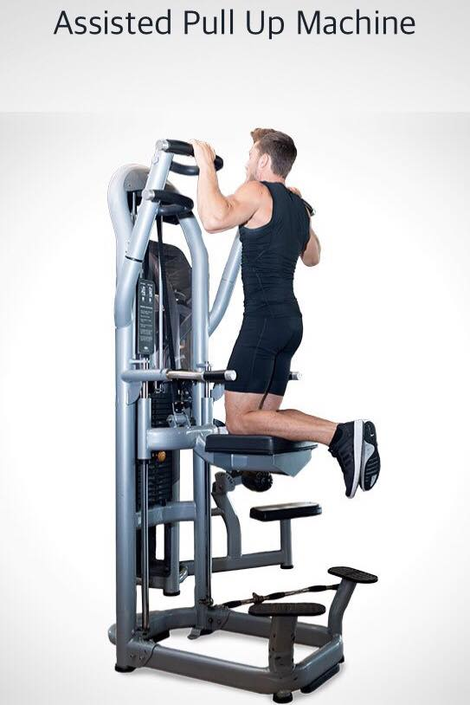

Primary muscle: Lats

Secondary: Biceps  
Instructions:

Preparation: Start by setting your weight. Stand on the side platforms while you hold the pull up handles. Carefully, put both your knees onto the padded knee rest.

Execution: Exhale as you pull yourself up. Inhale as you lower your body until your arms and shoulders are extended and repeat.

Menu

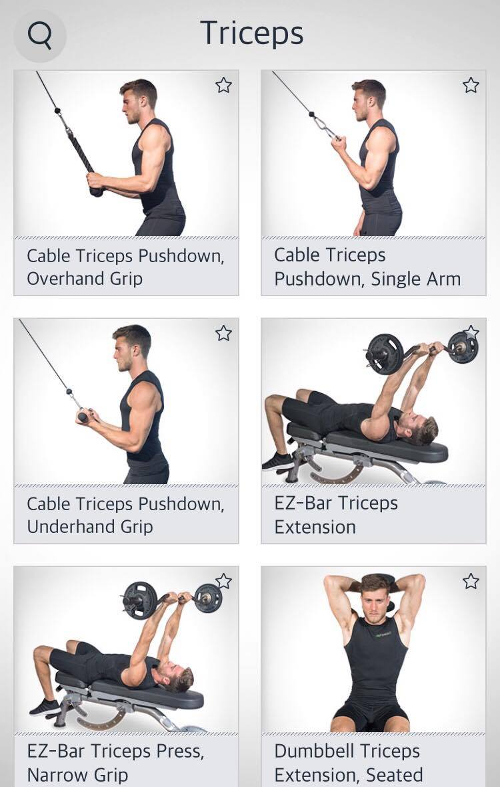

Menu

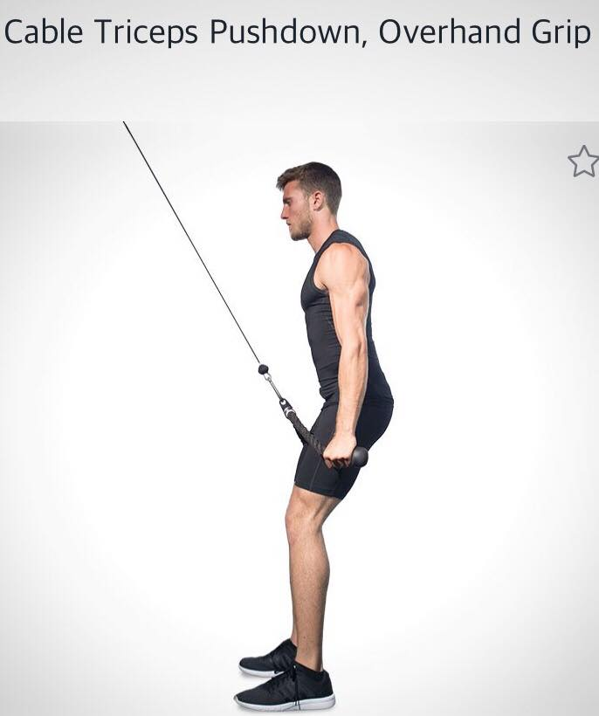

Primary muscle: Triceps  
Instructions:

Preparation: Attach the rope to the high pulley. Hold the rope in an overhead grip, facing the machine.

Execution: Exhale as you push down with your triceps, keeping your arms close to your sides. Return to start position and repeat.

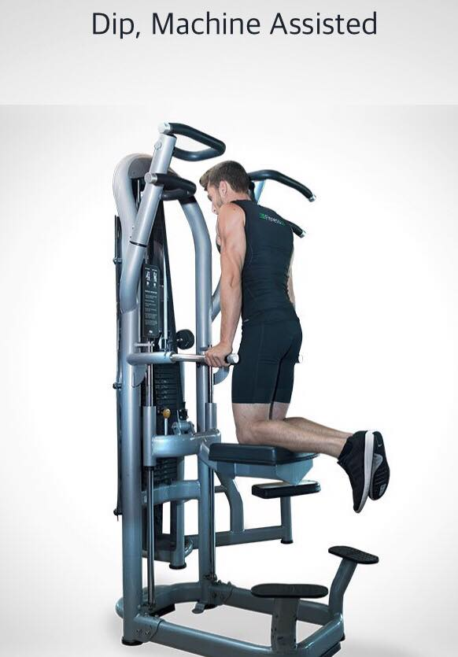

Primary muscle: Chest

Secondary: Triceps  
Instructions:

Preparation: Stand on the bottom step and grasp the handles with a neutral grip. Adjust the weight accordingly (more weight equals to more assistance). Start with your elbows bent and your chin tucked in.

Execution: Kneel down and inhale as you lower your body and exhale as you push your body up until your arms are fully extended and repeat.

Menu

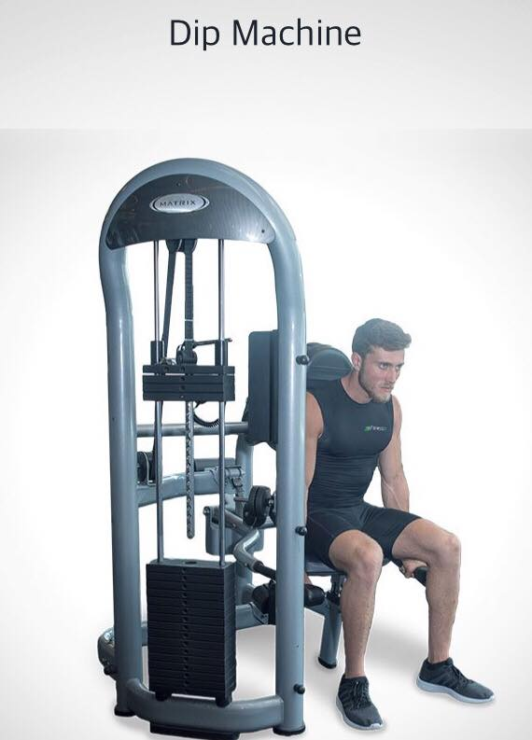

Primary muscle: Chest

Secondary: Triceps  
Instructions:

Preparation: Sit down, select your weight and grab the handles with your elbows bent.

Execution: Exhale and push down with your triceps, while keeping your elbows close to your side. Inhale as you return to stat position and repeat.

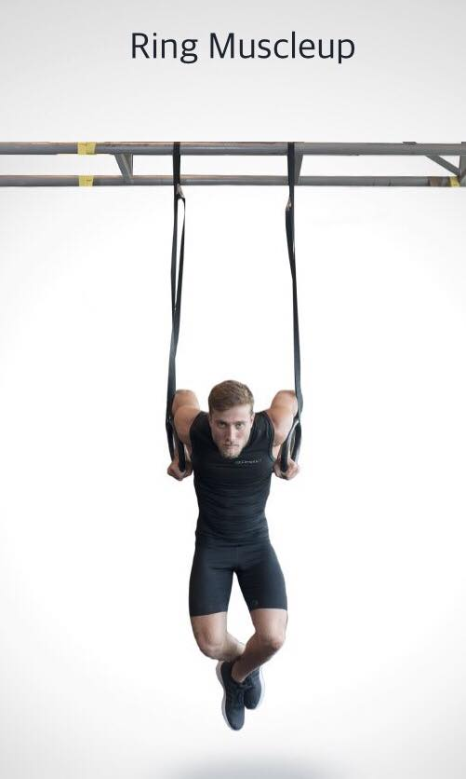

Primary muscle: Lats

Secondary: Biceps, Triceps  
Instructions:

Preparation: Start in a dead hang with shoulders touching your ears.

Execution: Pull yourself up as your hands rotate and when the pull reaches the peak, push your head up and over the rings, while also raising your toes up and push your body up like a normal dip. Complete the muscle up with your elbows in full lock out.

Menu

**Flexibility**

Body Stretcher Pick

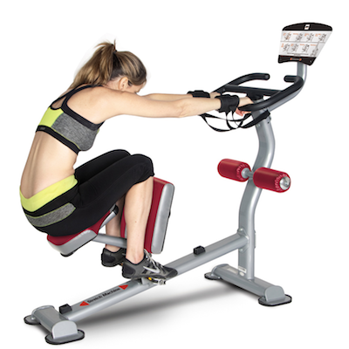

Primary muscle: Stretching

Secondary: Biceps, Abs  
Instructions:

Preparation: Sit down, select your workout length and grab the handles with your hands.

Execution: Pull yourself up with the kneel pedal go all the way up then all the way down. Exhale while you are going up and inhale when you are going down.

Top Leg Stretcher

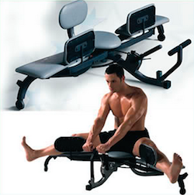

Primary muscle: Leg

Secondary: Biceps, Back  
Instructions:

Preparation: Sit down, select your weight.

Execution: Push out with your legs then go back to the starting position. Exhale while you are opening and inhale when you are closing.

Menu

Motive Fitness TotalStretch

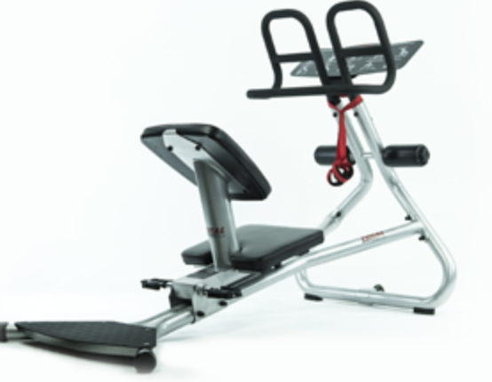

Primary muscle: Full body stretching   
Instructions:

Preparation: Sit down, put your arms and legs on the correct sides.

Execution: One your hands are on the handles and your legs stretched on the pedals try to touch your knees with your forehead. Do this process for 10 seconds then repeat 3 more times. Inhale and exhale.